The link to the app: <https://titanic-streamlit-simap.herokuapp.com/>

Below a view:

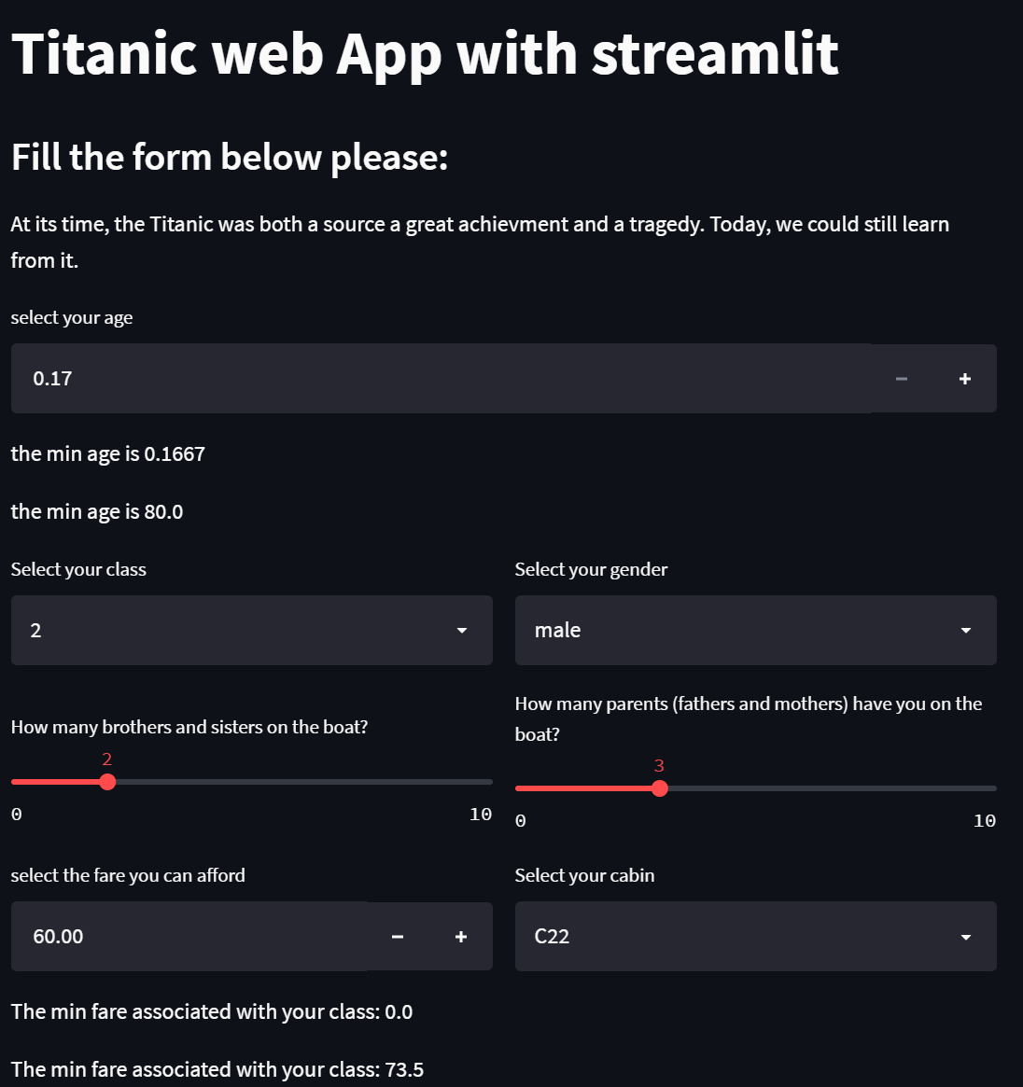

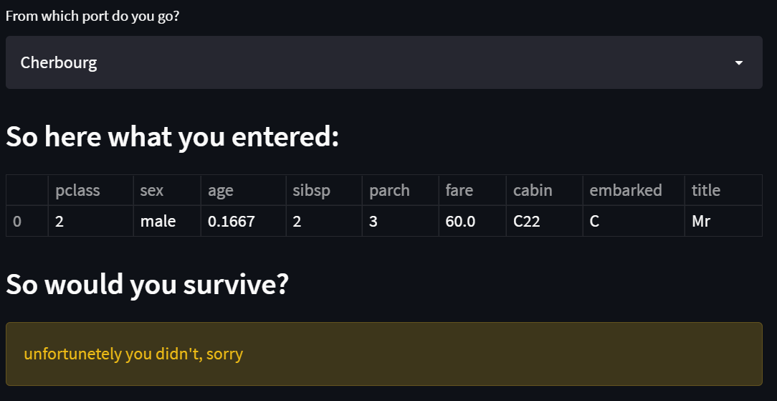

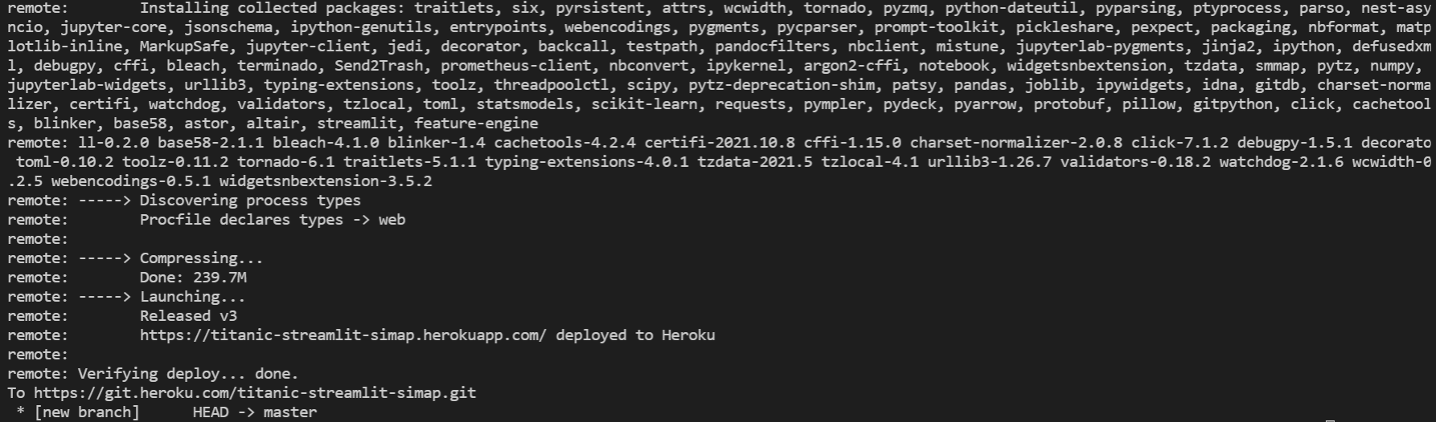

You should see the picture above after typing the command **git push heroku HEAD: master**